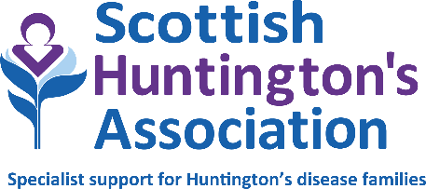

Person Specification

Role: Senior Huntington’s Disease Specialist
Organisation: Scottish Huntington’s Association
Date prepared: August 2025

 | Essential | Desirable
- Qualifications and training | Registered Nurse or Allied Health Professional qualified to degree level. | Specialist practitioner
- Knowledge and experience | Significant experience working in the community as a Nurse or Allied Health Professional.  Line management experience
- Skills | Clinical and interpersonal:  Highly skilled in carrying out complex specialist interpersonal assessment and interpretation followed by appropriate action.  Experience in managing hostile or antagonistic behaviour.  Ability to communicate sensitive, complex and at times contentious information.  Client care:  Taking the lead and responsibility for delivery of service in local area.  Expertise and knowledge as an accomplished practitioner.  Ability to support those who assess, develop and implement programmes of care with an inter/ multidisciplinary approach.  Planning and organising:  Delivery of activities/ programmes and all areas of local service provision.  Ability to think ahead to establish an efficient and appropriate course of action for self and others, considering relevant issues.  Effective time management skills and ability to meet deadlines.  Competence to organise and manage multiple priorities and the ability to successfully prioritise tasks for yourself and your team.  Financial management:  Management of inventories, payments and budgetary control as agreed by the direct line manager.  Education and training:  Facilitation of learning for small and large groups, with a good understanding of how adults learn.  Delivery of this service to paid and non-paid trainers.  Inputting to provision of resources for service users.  Reporting:  Including carrying out audits, as necessary.  Staff/student supervision:  Supervising and supporting colleagues and students as agreed with direct line manager.  Knowledge of data protection and confidentiality:  Understanding and applying the principles of data protection and confidentiality across all areas of work.  IT skills:  IT proficient, including Microsoft Office, PowerPoint and other relevant software programmes.
4. Attributes | Strong leadership and decision-making abilities.  Excellent speaking and listening skills.  Excellent attention to detail.  Effective networking and influencing skills and the confidence to deal with people of all levels of seniority.  Effective written and verbal reporting skills.  A good communicator (face-to-face, online, virtual etc.) with ability to create and maintain relationships.  Competence to plan, organise and manage multiple priorities and the ability to successfully prioritise tasks for yourself and your team.  Effective time management skills and ability to meet deadlines.  Teamwork/relationship building - building and maintaining relationships and working co-operatively and collaboratively.
5. Personal qualities | Keen to share knowledge while learning from others.  Analytical thinking - ability to critically evaluate information which can often be complex, with a good understanding of motives and behaviours.  Leadership and influence with ability to present sound and reasoned perspectives.  Interest in developing and nurturing others to maximise potential.
6. Other | A clean driving licence and access to a vehicle daily.  Commitment to, and promotion of, equal opportunities and anti-discriminatory practices at work.  Awareness of personal responsibility in relation to health and safety.  Willingness to undertake, and support others to, participate in professional development.

Aug 2025
Huntington’s Association is a wholly Scottish charity and is registered in Scotland as a company No: 121496.
Registered Office: Business First, Burnbrae Road, Paisley, PA1 2FB

